Sales Analysis using Hadoop MapReduce – Top Products by Total Sales

1. Objective
The objective of this experiment is to analyze sales data using Hadoop MapReduce and identify the Top 5 products based on total sales. Hadoop Streaming with Python Mapper and Reducer programs is used to process large-scale sales data stored in HDFS. The experiment also performs city-wise product sales analysis.

2. Procedure

Step 1: Create Sales Dataset
Create a dataset containing Date, Product Name, Price, and City.

Step 2: Generate Large Dataset
Replicate the dataset multiple times to simulate a large volume of sales data.

Step 3: Create Mapper Program
Develop a Python mapper program to extract product names and corresponding sales amounts.

Step 4: Create Reducer Program
Develop a Python reducer program to calculate total sales for each product and identify the Top 5 products based on total sales.

Step 5: Upload Dataset to HDFS
Create HDFS directories and upload the sales dataset.

Step 6: Execute Hadoop Streaming Job
Run Hadoop Streaming MapReduce jobs using Python mapper and reducer scripts.

Step 7: View Results
Display the output stored in HDFS and identify the top-selling products.

Step 8: City-wise Product Analysis
Create a city-wise mapper to analyze product sales across different cities.

3. Source Code

Dataset Creation
cat > sales_products.txt << 'EOF'
2024-01-01,Laptop,45000,Delhi
2024-01-01,Mouse,1500,Mumbai
2024-01-02,Keyboard,3500,Bangalore
2024-01-02,Laptop,45000,Chennai
2024-01-03,Mouse,1500,Delhi
2024-01-03,Monitor,25000,Mumbai
2024-01-04,Laptop,45000,Bangalore
2024-01-04,Keyboard,3500,Delhi
2024-01-05,Monitor,25000,Chennai
2024-01-05,Mouse,1500,Mumbai
EOF

for i in {1..50}
do
cat sales_products.txt
done > sales_products_large.txt

Mapper Program (mapper_top_products.py)
#!/usr/bin/env python3

import sys

for line in sys.stdin:
line = line.strip()

if not line:
continue

parts = line.split(',')

if len(parts) != 4:
continue

try:
date = parts[0]
product = parts[1]
price = float(parts[2])
city = parts[3]

print(f"{product}\t{price}")

except ValueError:
continue

Reducer Program (reducer_top_products.py)
#!/usr/bin/env python3

import sys

current_product = None
total_sales = 0
product_sales = []

for line in sys.stdin:
line = line.strip()

if not line:
continue

product, price = line.split('\t')
price = float(price)

if product == current_product:
total_sales += price
else:
if current_product is not None:
product_sales.append((total_sales, current_product))

current_product = product
total_sales = price

if current_product is not None:
product_sales.append((total_sales, current_product))

product_sales.sort(reverse=True)

print("TOP 5 PRODUCTS BY SALES:")
print("=" * 40)

for i, (sales, product) in enumerate(product_sales[:5], 1):
print(f"{i}. {product}: ₹{sales:,.2f}")

Create HDFS Directory
hdfs dfs -mkdir -p /user/$USER/sales_products/input

Upload Dataset to HDFS
hdfs dfs -put sales_products_large.txt /user/$USER/sales_products/input/

Hadoop Streaming Command
hadoop jar $HADOOP_HOME/share/hadoop/tools/lib/hadoop-streaming-*.jar \
-input /user/$USER/sales_products/input/sales_products_large.txt \
-output /user/$USER/sales_products/output \
-mapper "python3 mapper_top_products.py" \
-reducer "python3 reducer_top_products.py" \
-file mapper_top_products.py \
-file reducer_top_products.py

View Output
hdfs dfs -cat /user/$USER/sales_products/output/part-00000

City-wise Mapper Program (mapper_city_products.py)
#!/usr/bin/env python3

import sys

for line in sys.stdin:
line = line.strip()

if not line:
continue

parts = line.split(',')

if len(parts) != 4:
continue

try:
date = parts[0]
product = parts[1]
price = float(parts[2])
city = parts[3]

print(f"{city}_{product}\t{price}")

except ValueError:
continue

Expected Output
TOP 5 PRODUCTS BY SALES:
========================================
1. Laptop: ₹6,750,000.00
2. Monitor: ₹2,500,000.00
3. Keyboard: ₹350,000.00
4. Mouse: ₹225,000.00

4. Screenshots

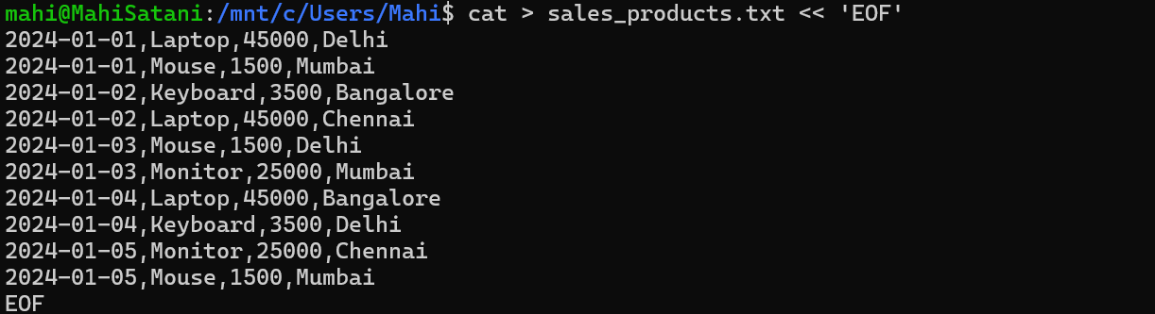
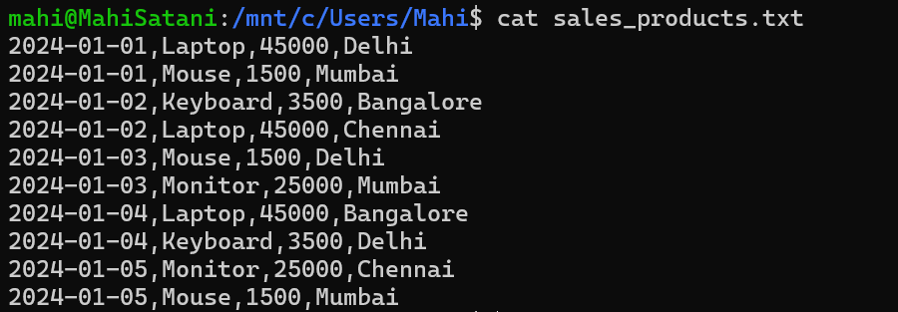
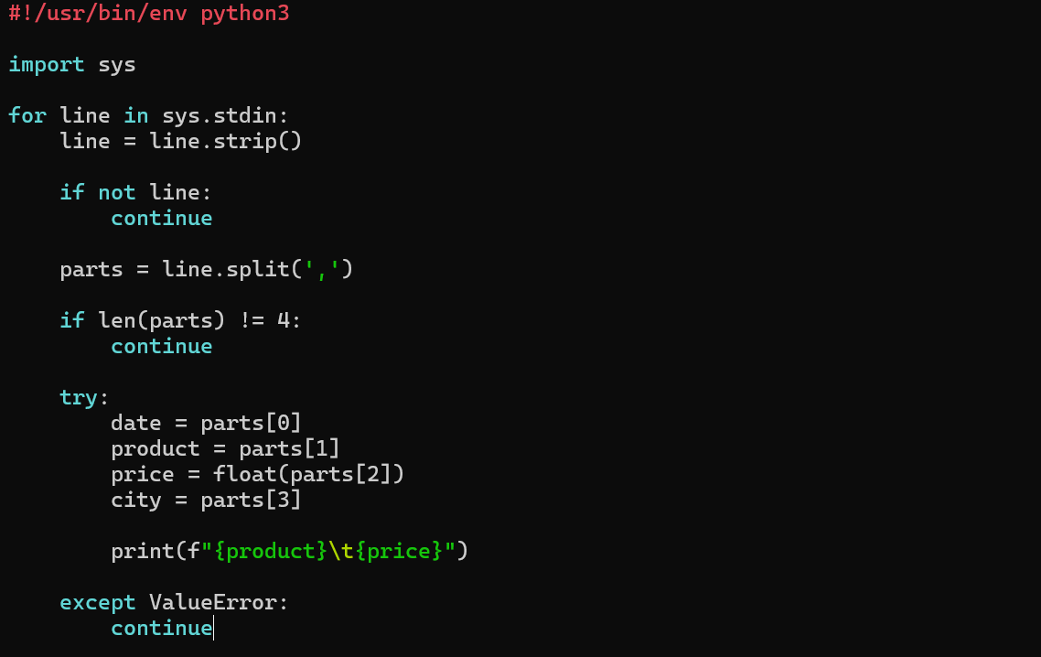
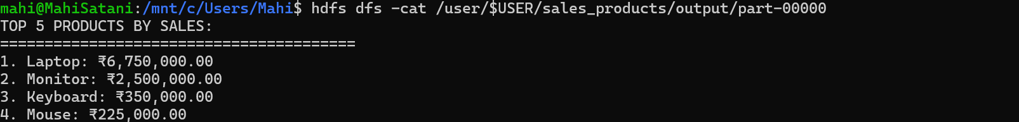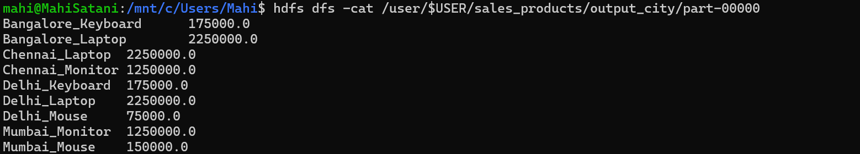

5. Conclusion
The sales dataset was successfully analyzed using Hadoop MapReduce and Hadoop Streaming. The Mapper extracted product sales information, while the Reducer calculated total sales for each product and identified the top-selling products. The experiment demonstrated how Hadoop can efficiently process large-scale sales data and perform product-wise and city-wise sales analysis.

